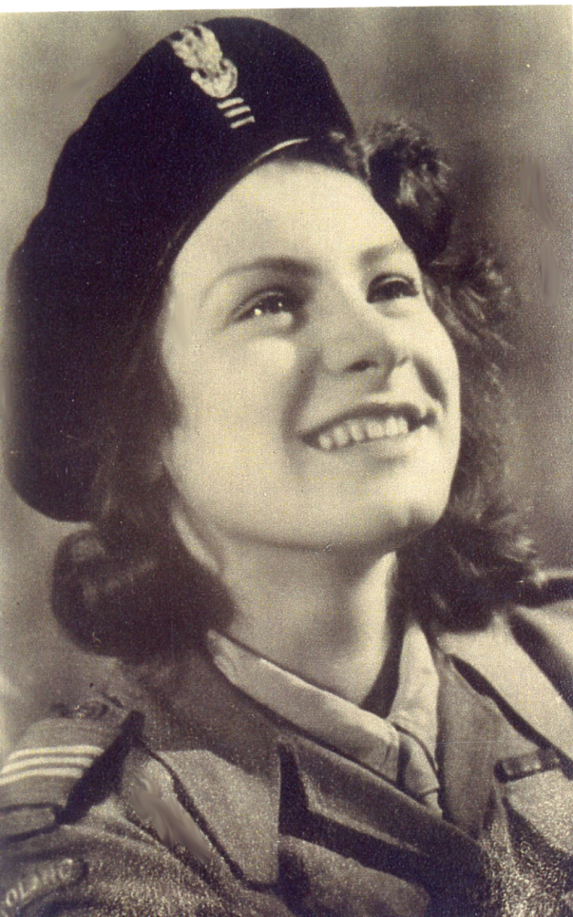
EWA PONIŃSKA-KONOPACKA, pseudonym „Ewa”
Eva Ponińska was born on the 4th May 1926 in Paris the only child of the Polish diplomat Alfred Poniński. From the fourth year of her life she lived with her mother in Poland. In 1931 when the first sigh of the tuberculosis was discovered in her lung she was sent to Rabka, a mountainous region of Poland, where she attended elementary school run by the Sisters of Nazareth. In 1938 she continued her education at the Sisters of Immaculate Conception High School at Novy Sacz.
In 1939, when the war broke out Eva with her mother left for Lwow and then in February of 1940 they tried to reach Eva’s father stationed as a diplomat in Bucharest, Romania. They were arrested by Soviet border guards on the Polish territory, for crossing the border illegally. They found themselves in the prison, first in Kolomyja, later in Stanislavov. Prisons were overcrowded with the political prisoners, mainly Polish officers and their families. Walls were covered with names and addresses of those who were send into unknown places. In the prison, men wore heavy chains on their legs and hands. In Stanislavov, Eva and her mother were placed in a cell originally meant for one person but there were already 8 women sitting on the floor. After spending one month in prison, Eva was released but her mother was sent to Kiev prison as a spy and later to a gulag. Eva reached Lvow and having nowhere to go she knocked at the door of casual friends and was warmly received. For one year Eva continued to attend High School studies at Lvow. When the occupational forces of Lvow changed hands Soviets left and German army took over the city in July 1941, Eva left for Warsaw to join her aunt. She left with terrible memories of unspeakable crimes committed by the Soviet secret police NKWD on political prisoners. Before Germans entered, Lvow, for one day the city was free. The moment Soviets left, people rushed to two prisons to liberate the prisoners. What they found were the tortured bodies some of them with heads covered in tar to make the recognition difficult. In one cell on Łącki Street, a Dominican monk was found crucified on the wall.
In Warsaw, Eva continued High School studies, although officially it was called a gardening school. Germans abolished Polish universities and higher education including high schools. Only trade schools were allowed. Soon Eva found out about the secret organizations and joined Girl Guides were also illegal. In February 1943 she was accepted as a member of the Polish Home Army. She finished courses as telephone operator and general courses in street fighting.
During the Uprising of 1944, she was member of a platoon 228 in telecommunication for division called “Żywiciel”. In the second month of the uprising she was moved to the group called “Żyrafa”. At first, Eva served as telephone operator then she repaired telephone lines broken by shrapnel, finally as a courier passing orders. During a concentrated attack of the German forces connection was lost with an important fortified building where the insurgents were under heavy attack, Eva volunteered to make connection. For this act she received the Polish highest war decoration for bravery the Virtuti Militari. After capitulation she became the prisoner of war and was sent to Stalag XIA Gross Lubars, then to Stalag VIC Oberlangen in Germany.
Stalag XIC Oberlangen was freed by the division of gen. S. Maczek on the 12th of April 1945. Eva left for Italy to become member of the 2 Corps of gen. Anders whose Corps was occupying Italy. She was able to finish the last year of high school in 1946. With the 2nd Corps she travelled to England where she was demobilized. Soon after she was offered a scholarship by the Polish Government in Exile and was sent to the National University of Ireland in Cork. After three years she received the B.A. degree in history and sociology. After one more year at London University, she obtained the Diploma in Education. For three years Eva taught in a Catholic high school in Port-of-Spain, Trinidad, and an English colony. In February 1954 she left for Canada, the same year she met her future husband Thaddeus Konopacki, whom she married in the fall of the same year. They lived in Montreal, Toronto and finally in Ottawa. For the first nine years Eva looked after their four daughters. In 1964 at the request of dr. Żurowski, she became one of the founders of the Polish Women Federation in Ottawa.
In 1964 she went back to teaching career and for 20 years she taught at the Catholic schools for the Separate School Board of Ottawa. She also took classes of painting at the Ottawa School of Art and developed an artistic career. Her paintings found their way to private collections in Canada and Poland. Four religious paintings can be found at the Catholic Church of St. Hyacinth in Ottawa. She is member of the Polish Combatants’ Association in Canada and works for the Polish Missions “Z Pomocą”. Eva and Thaddeus have four daughters who speak Polish and seven grandchildren.

WAR MEMORIES
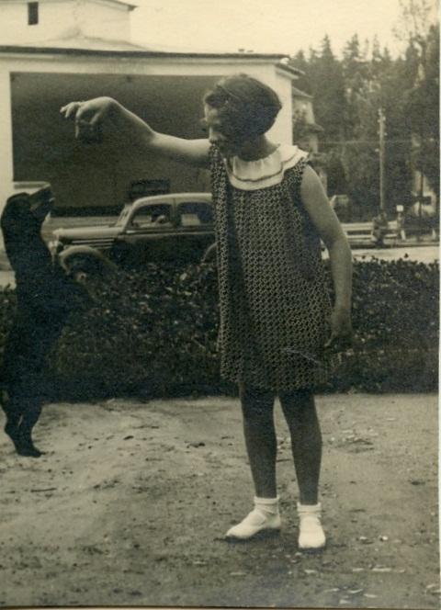
Eva in 1936
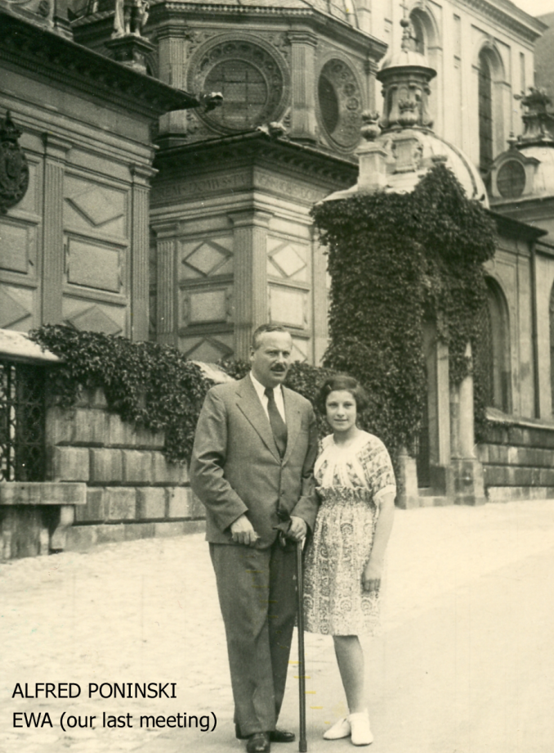
June 1939 – with my Father
In September 1939 the German army, at Hitler’s bidding, hit Poland with all its might – changing the course of history not only in Europe, but in the whole world. In Novy Sacz, the convent high school became a hospital – meant a prolonged vacation to all us school children. The grim fact the hospital would be filled with casualties somehow didn’t sink into my mind. I plastered the long strip of newspaper to the window panes, to protect them from breaking in case of bombardment. For me at thirteen, the war seemed an exciting adventure.
When our school became a hospital, my mother Anna decided to travel to Eastern Poland. She hoped that the school at the other end of the country would stay open and continue teaching. She thought that in the east everything would be peaceful. But on the journey we our first taste of war: our train was bombed and strafed a number of times. People were killed and wounded. My concept of war as an adventure was changing rapidly.
But when we reached the convent school, near Kowel, close to the Soviet border, everything there did seem calm. Poland had a peace treaty with the Soviets, and no danger was expected from that side. But what did we know about politics? The fate of Poland was already sealed by the secret treaty between Hitler and Stalin, tearing Poland into two and sharing the spoils between them. While the Polish army was in a deadly struggle with German armoured troops, the Soviet army would begin crossing Poland’s eastern border under the false pretence of bringing help against the Germans.
When we arrived at the school, it was already filled with refugees. The nuns did their best to feed everyone. I still remember the large park around the convent, with walnut trees covered with fresh crops of nuts. They were delicious.
Three days late, early in the morning, I heard voices singing a strange song. My mother woke up too and listened. “Only Russians sing like that – that’s a Russian song,” she said in disbelief. That was the day the Russian army entered Poland.
The new authorities closed the convent, and the nuns and refugees had to disperse. We went to Lvow the largest city in Eastern Poland. Lvow, “the city of the lion”, was built by the Polish monarchs, aristocracy and rich merchants, and was known for its beauty and fine architecture. Again we found refuge in the convent, the Contemplative Order of St. Claire on Kurkowa Street. The ascetic life of the nuns, normally spent praying day and night, was now dedicated to caring for the refugees. We crowded into their cells and corridors by the hundreds, and they fed us homemade soup once a day.
In January 1940, my mother decided to cross the Polish-Romanian border to reach my father. As far back as I could remember, my parents’ lives had gone separate ways, although my father provided for me and often wrote to me. But now we were at war, and my mother decided to seek his help. Romania was still a free country, and my father held an important position as a charge d’affaires at the Polish Embassy at Bucharest.
The Polish border with Romania was guarded by the Soviets, but local farmers would guide groups of people across secretly for a price. This illegal crossing was called “the green border”. Many young men crossed to join the Allied Forces in the West. My mother made the arrangements; and on the appointed day, she and I took the train from Lvow to Sniatyn, a border town. There only a few people on the train, mainly local peasants in their country garb, and I felt uncomfortably conspicuous wearing my navy blue winter coat with the school emblem on the sleeve.
We arrived at Sniatyn late at night and travelled by sleigh through the snow to a little farm house, where we stayed until the time arranged for our crossing. Two men were to cross the border with us. One was a short middle-age university professor from Poznan, called Maricz; the other tall and burly Polish army colonel called Jampolski.
The night of our crossing was very dark and cold, with no moon. We walked across the fields in single file, in complete silence. The snow crackled under our feet and our breath formed white clouds above our heads. After a long march, we were so close to the border that we could see the lights from the Romanian train station. All we had to do now is to cross a wooded area and then the frozen River Dniestr. I though5tr of the surprise my father would get when we arrived. He always loved, trying to make up for not being with me. He came to see me as often as he could, wrote long letters, and sent me picture books from the countries he visited.
But the moment we were among the trees, my reverie was broken by laud shouts in Russian: “Ruki na vierh! – hands up!” At once we surrendered by the white silhouettes of armed Soviet border guards, who had been hiding behind the trees. Their long white fur coats made practically invisible. (We later found out that this was a trap, arranged in advance by our guide.)
Everybody put their hands up, and I did the same. My mother and I were on one side of a small clearing, away from the men. Seeing us standing there, one of the Russian soldiers shouted, “Turn around! “ At that moment, I was sure that he is going to shoot us, but nothing happen to us then.
Out of the corner of my eye, I saw one of the guards viciously kicking the Colonel and hitting him with rifle butt.
Then we were led to the guard house, and everybody but me was interrogated all night. I was told that as a child I have to sit quietly. An armed guard accompanied me to the washroom.
Next morning we were put on the train with guards and taken to the old prison in Kolomyja. Though the prison we led through the long corridors. Suddenly we told to stop and face the wall: the guards wanted to prevent us from seeing another group of prisoners that was coming. Still, I managed to turn my head slightly and look. What I saw heart my heart: thin bearded men wearing Polish uniforms – with heavy irons on their hands and legs.
We were taken to a large hall to wait until we were assigned to cells. The walls were all covered with scribbled messages: “We are taken to a gulag in the Soviet Union, please notify our family.” “The transport is leaving tomorrow, destination unknown.” There hundreds of names and addresses. We found out
later that most of the prisoners were Polish officers, judges, teachers and community leaders.
The conditions in the Kolomyja prison were terrible. The cells were overcrowded; and instead of toilets, we only had large buckets. (Many prisoners suffered from diarrhoea, and had to use the buckets quite often – which caused some nasty remarks.) On our first day, everybody was taken to the showers. We had to remove all our clothing and stand naked while the male guards distributed small pieces of hard, sand soap. It was February and there was no heating in the prison; the shower water was freezing cold. Afterwards we had to wait, shivering, for our clothing to be returned: it had been taken for delousing. We protested that our clothing was clean, but the regulations demanded every garment to be cleaned. When we finally got our clothing back we found a few stunned lice inside, which had come from other prisoners’ garb.
After only three days in Kolomyja, we were taken by train to Stanislavov, a much bigger city. The prison there was built before the war to house criminals; now the Soviets used it for political prisoners. The large prison was eight stories high and rectangular in shape, with a big covered courtyard in the centre. All the cells faced the courtyard, and all doors had a viewer for the guard to watch the prisoners.
Our fourth-floor cell had only one bed – but there were seven women in the cell. One occupied the bed the others sat or lay across the floor with their feet under the bed. We soon realized that all the women were the wives of Polish officers, except the one on the bed. She, we were told in whispers, was a petty thief acting as an informer for the police. We were glad to have her at distance, because she was covered with lice.
Those who slept on the floor stayed as far as possible from the leaking toilet at the end of the cell. The electric bulb was lit all night. We were so crowded that during the night everybody had to turn over at the same time – though the advantage was that it kept us warm. The prison was not heated, and the glass in the little window close to the ceiling was broken. My mother who liked fresh air, slept under the window. I was next to her. We wore our winter coats all the time, except for the few moments each morning when we removed all our clothing to check for lice.
During the day the women tried to forget the present by talking about their families and their normal lives before the war. One young woman hoped, foolishly, that she would be relisted soon: after all, she hadn’t done anything wrong. None of us could guess that Stalin had ordered the total destruction of the Polish upper class – not just officers and their wives and families, but thousands of policemen, judges, intellectuals, businessmen, or anyone with an education who held a civil or religious position. Although these people had never fought against the Soviets, they were all accused of espionage. A year later 25,000 would be shot and buried in mass graves.
Our breakfast consisted of a cup of hot brown liquid and a thick slice of bread. At noon we had a bowl of thin soup; and for supper, some more brew. The only advantage of drinking this was that it was hot. From the bread which had the consistency of clay, my mother made three small balls and taught me how to juggle. The most popular topic of the conversation was food. Everybody talked about what they would like to eat, and to prepare delicious dishes. My dream was to eat a piece of buttered white bread with a thick slice of ham.
During the day we sat on the floor, and at night we slept in the same place. One day we were told that those who wished could take a walk. My mother and I, and a couple of other women, decided to stretch our legs. We were taken to an open courtyard. There were prison buildings on three sides, and the forth there was a two-storey brick wall with barb wire on the top. We had to walk around the courtyard in a single file, our hands behind our backs. We looked exactly like Van Gogh’s painting Prison Court. Although the walk lasted only 15 minutes I was frozen nearly to death and never volunteered again.
At night, interrogations were held. Being underage I was never interrogated, but my mother was taken several times: like everybody else, she was accused of espionage. At one interrogation, after we had been at Stanislavov for three weeks, she was told that she will be moved to Kiev prison in the Soviet Union. Now she had to decide about my future. She was told that she had two choices: I could be placed in the Soviet orphanage, or sent to relatives. To save me from the orphanage, my mother told the KGB that we had relatives in Lvov. In fact, they were only acquaintances.
Parting was heart-breaking for both of us, but especially for my mother, who had to stay in prison and send away her only child to an uncertain future. We didn’t know if we would ever see each other again. After short goodbyes, the KGB agents drove me to the train station and put me on a train going to Lvov, with a transport of the Russian soldiers. Soldiers absorbed in their card game didn’t pay any attention to a pale thirteen-year old; and as soon as we reached suburbs of Lvov I slipped off the train, afraid that somebody might try to stop me.
Full of anxiety, I knocked on the door of our casual friends, whom I had met only once before. But I needn’t have worried: they received me very kindly. Mrs. Szwabowicz was an elderly widow whose three grown daughters lived with her. Even though the times were hard and they didn’t have much, they still took me in. (A month later, they took another refugee girl.)
First of all, their maid Mary gave me a thorough bath and washed my hair with a special soap to kill the lice. Then, for the first time in many weeks, I slept in a bed with clean sheets. It was a wonderful feeling. But a few days later, I developed a high fever and became very ill. Mrs. Szwabowicz called the doctor. I was too week to ask what was wrong with me, and never did find out. It took me a full month to recover.
After my suffering in prison, normal life was wonderful to me – I was even grateful to be back at school! Because of the war I lost a year; now I was to pick up at the Grade Eight level. Our coed school was still called Stefan Batory, the name of the powerful Polish king who had ruled Poland in the sixteenth century. The Communist dictated curriculum: as well as mathematics, history, geography and literature, we also studied Russian, Ukrainian and the history of Marxism. (Religion was not part of the school program, but was secretly taught by the Dominican Friars at the nearby church.) I made my way to the top of the class – competing fiercely with another student, Stan. We liked each other although his father was a Communist. As a head girl of our class, I organized tutoring for students who were behind with their school work also Stan often stayed after school to help other students.
Twice a week we had gymnastics lessons, accompanied by piano music. The piano was played by a striking looking woman; young, with luminous dark eyes, short black hair and pale complexion. She never used any make up and was always dr3essed in black. I still remember her sweet, gentle smile. Her name was Fulla Horak, and she would often play piano after school just for pleasure. I stayed and listened; and one day she asked me if I would like to take piano lessons. I explained that I had only just started lessons before the war, and was still a beginner. She told me that she would give me free lessons if I wanted.
Soon she became my teacher and my best friend. I often went to the other end of the city to visit her in her small apartment. She lived with an elderly woman who was her companion and served her as best as she could. You could see that she loved her. She told me one day that Fulla prayed a lot and had religious visions. I thought that she might be a nun in the disguise. Our friendship lasted until I had to leave Lvov. In her presence I found encouragement to help me fight off fits of depression
It was during that time that I decided to be confirmed in the Catholic Church. Times were hard, and I wanted to become a fully-fledged member of the Catholic Faith. The Sacrament of Confirmation was given by a bishop at the ancient Lvov cathedral. It had a severe and lofty look, supported inside by enormous columns branching off high above into graceful arches. The faint and mysterious light came through the long stained glass windows. Even in the summer, the interior remained cool and dark. But on that day of confirmation, the cathedral was filled with light and crowds of people came to watch the many young people receive the sacrament. I chose Mary Mother of God and St, Theresa as my patrons, and a stranger put a hand on my shoulder as a witness.
Otherwise, the winter of 1941 was bitter, with gloomy weather and strong winds. I was depressed: I worried constantly about my mother, and found it hard to adjust to living with a new family. As an only child I had always been the centre of attention, and my mother was very affectionate. Suddenly I found myself alone, burden to the people I lived with. Although Mrs. Szwabowicz was a good and religious woman, she was cold and reserved by nature. I could never expect any hugs from her.
Looking back, I realized later that I had been spoiled, with completely wrong priorities. One day while I was practicing my music for Fulla, the maid began to sweep the room. When she reached the piano, she asked me to move out of her way. I ignored her request, feeling that practicing the music was a far more important task than cleaning – that could be done any time. But the maid, who was a husky woman, didn’t discuss the subject: she just removed me physically from the stool and placed me in another room. \i shocked, and I felt that a terrible injustice had been done. I went to Mrs. Szwabowicz and complained bitterly – and to my surprise and humiliation, I was told never to interfere with the maid’s work. I was learning my lesson.
The change was too sudden for me to accept easily. Before the war, I had been drenched with affection by my grandfather and my aunts Sophie and Mary. And I was accustomed to being treated as an adult: although I was only thirteen, I had a vast knowledge of arts and literature. Now, no one was interested in what I had to say, and I found the coldness and rejection very hard. When I walked alone through the streets of Lvov, I thought of suicide. But that was just wishful thinking; I was too religious to seriously consider committing a suicide.
The grocery stores were totally empty, there was nothing to buy. From time to time a truck would arrive with bread and sugar, and immediately a long line formed – sometimes more than two kilometers. Quite often you had to get up at three o’clock in the morning to get a good start. After two or three hours, somebody else would replace you,; and so on until you got some bread, or occasionally a piece of meat. Quite often, after people spent hours waiting, the store would run out of food and people had to go home empty-handed. Sometimes we waited in cold so bitter that I had open sores on my fingers and toes from frostbites.
At one point, my life brightened up for a while with the hope of escaping. I have no idea how my father found out where I was, but he sent visas through the Romanian Consul for me and two of my cousins, I had discovered them quite unexpectedly. They were both refugees from north-eastern Poland: Katherine who had a one-month son Andrew and her sister Theresa.
Day after day we stood in lines at the KGB offices with other foreigners trapped by the war. We filled out endless forms, only to be told to come back next day. Unfortunately, it soon became clear that although the Soviets did supposedly allow people with official Romanian visas to leave Poland, the authorities were not prepared to let them go.
After two month waiting for the permission, everything changed in one day. That day, thousands of people were forcibly arrested during the night and put on cattle trains for Siberia. Among them were Theresa, Katherine and her baby son. The ethnic cleansing had begun.
Being sent to Asiatic parts of the Soviet Union – Siberia or Vorkuta – was everybody’s greatest fear. Cattle trains loaded with Polish families were leaving every day. In our apartment building, one family after another had been taken away. One night it was a family living above us; we waited tensely for our turn to come – but for some unexplained reason, it never did.
In all, at that time about two million Poles were forced out from their homes and sent to gulags in Siberia, Kazakhstan and Vorkuta. Those who left were allowed to take only two suitcases, and had to leave behind their homes, furniture and all their other possession. These were taken over by Russian families.
The German friendship broke down unexpectedly in June 1941, when Hitler attacked Soviet Union. After short bombardment, Lvov was taken by the German troops without the fight. People run to the prisons to free the thousands of political prisoners arrested by the Soviets. They found them all dead. Although the Soviets left in a hurry, they had found enough time to murder the prisoners. Some were tortured to death – among them priests and nuns. One Dominican priest was crucified on the wall in his cell. In one prison the heads of the murdered victims were covered with tar to make them difficult to identify. The bodies were laid out outside the prisons for the relatives. It was July and the stench of decomposing bodies spread over the city.
One enemy has left, and another arrived. Soon I was to learn the extend off the tragedy of the German army arriving. Almost their first act was to arrest and execute all the university professors of Lvov University and their families. |Other signs of the new order were soon to appear. I went to see my friends Adam and his wife Janka, whom I met at the beginning of 1941. Adam was a layer, and they had two children about my age. They often invited me for tea and we had long and interesting discussions. They had a big library and gladly let me borrow their books. I enjoyed the company of these warm and friendly people.
When I went to see them in July, after the Germans entered Lvov, they were anxious and depressed. They told me that from now on they would have to wear the Star of David on their sleeves. I was quite shocked; I even didn’t know they were Jews. A few days later, they told me they would have to leave their lovely apartment and move to the ghetto, an area designated for the Jews by the Germans. Some people went into hiding. Adam’s family decided against this, because it would mean splitting up, and they went to the ghetto together. Janka wasn’t Jewish, but she said she would go wherever her husband and children went.
Once Lvov was in the hands of the Germans, I could send a letter to my aunt in Warsaw. Her answer came quickly: she paid a man to come to Lvov and bring me to her. Before I left to begin my new life in Warsaw, I said goodbye to Mrs. Szwabowicz and her daughters, and to All my friends – especially Fula Horak, and Adam and Janka. I never saw Adam’s family again.
Soon I was living with my Aunt Mary and her hu8sband Zygmunt in a suburb of Warsaw called Bielany. My grandfather lived in an apartment below in the same building, and Aunt Mary took care of him. She asked me to take dinner to him every day, and we would chat. He was an engineer; and although he was eighty. He was in very good physical and mental shape. He was working on an invention that he felt had a great future after the war.
I began to attend high school in Warsaw, and every day I had a long trip by streetcar. The streetcars had a special section in front, reserved for Germans only. Nazi Germans regarded themselves as a master race, and would not mix with Poles. There were also security reasons for the segregation: Germans felt very unsafe in the company of Poles – and for good reason.
But when my grandfather took a streetcar, he would always sit in the front part. I asked him why he did this, as he could be arrested for it. His answer was: “I am in my own country, and I will sit wherever I want.”
My new high school at Invalid Square, in Warsaw was officially designated as gardening school to satisfy the Germans, who only allowed trade schools for Poles – they had abolished all secondary education and universities. Despite these changes we maintained a patriotic atmosphere, because the teachers were the same as before the war. We learned the official curriculum subjects at school, and in private homes we learned forbidden subjects such as Latin, history and Polish literature.
Soon after joining the school, I was introduced to an underground organization of scouts and guides that prepared young people for the underground army. Our troops were called “The Bulls”, because we were all born under the sign of Taurus. We had plenty of adventure, and the day was always too short for everything we students had to do – especially since there was a police curfew at 8 p.m., and everybody had to be home by then. (One of my courses was First Aid, and I was assigned to give my grandfather the injections he’d been prescribed. After my first try, he asked me gently – “Can you find a thinner needle next time?!”)
We also trained in proficiencies that would be useful during the war. When we learned to use automatic pistols and revolvers, our excitement was accompanied by fear of being caught and tortured. We used pseudonyms for safety in the underground, but of course we all knew each other’s names from school. Sometimes, I would ask myself: “Could I withstand torture without revealing the names and addresses of the other underground members?” I couldn’t answer that question.
Reprisals for underground work were brutal. The Germans often took hostages from people travelling to work. Their names were printed on the large red posters throughout Warsaw, announcing that fifty hostages would be executed if any sabotage occurred anywhere in the country. The result was always the same: fifty hostages were publicly executed on one of Warsaw main Streets. The executions were usually carried out during the lunch hour, when the streets were packed with people. German soldiers arrived in the army trucks to close off the street, and those who were there had to watch the execution. The hostages were brought in by military trucks, lined up against the wall, and shot in bursts of machine-gun fire. The bodies were taken away, and the superintendent of the building where the execution had taken place hosed away the blood on the pavement. A few hours later, flowers and lighted candles appeared in front of the wall were fifty lives had just been snuffed out. People said furtive prayers there. Later, the Germans would fill the young men’s mouths with plaster before executing them, so they wouldn’t shout “Long live Poland,” before their death.
My aunt didn’t realize for several months that I was a member of the underground movement. But one day I came home after the curfew, and she was anxiously waiting for me at the door. She was afraid I’d been arrested. She was so distressed that she turned pale with relief and fainted when I finally came in. But when she recovered, she asked me directly if I was member of the underground organization. When she found out the truth, she packed me off to a boarding school run by the Sisters of Nazareth – so I couldn’t do underground work for a year. Then the school was closed and I had to come home. By this time my aunt had accepted the inevitable: that all young people had to fight the invaders.
In 1943 I took the underground soldier’s oath in the presbytery of the church, witnessed by a priest who was himself a member of the underground. I promised to serve my country faithfully, and to keep the secrets of our organization even in the face of death. Then we went back to our training.
I took special courses in communication – learning how to build and repair telephone lines, and how to service army telephones and switchboards. We also learn military skills such as the techniques of street fighting.
Life was dangerous, and practically everything we did carried the death penalty. As a result nobody paid much attention to the German rules, although the consequences could be tragic. Patriotic youth was often arrested, tortured and killed, or sent to concentration camps to die a slow death. But that didn’t stop us. On national holidays, we decorated historical monuments with flags and flowers. We also painted walls with the anchor emblem – the sigh of hope and struggle. It was shaped to spell out the words “Poland is fighting.”
Heinrich Himmler had begun organizing concentration camps on Polish territory back in 1940, to terrorize the population. The first ones were built at Auschwitz and Stutthof. The first transport of 728 Polish prisoners arrived there on June 14, 1940 – nearly all of them the young men caught trying to escape to join the Allied Army. Over the next few years, more than two hundred camps were built. Their purpose was to provide the Germans with slave labour, before the prisoners died from undernourishment and sadistic treatment.
And in 1940, the Germans had begun a systematic campaign of exterminating the Polish Jews in the ghettos through starvation diets. A worker requires an average of 2,400 calories a day – the Jewish workers were given 184 calories. But though the Jews were dying of starvation, it wasn’t fast enough for the Germans; and in summer of 1942 they began their policy of immediate mass murder, liquidating the ghettos.
The final destruction of the Warsaw ghetto came in 1943. I had travelled through it a few times in a streetcar, and it was like seeing a tragic foreign land. The gates in the high walls were guarded by the armed soldiers, who made sure that no one got in from the outside to bring relief. I saw overcrowded streets, with many emaciated people sitting starving on the sidewalk. Some looked at the streetcar as if it were an apparition from another world. The ghetto was the city within a city, ruled by other laws than the rest of the country. Its inhabitants were a people marked for immediate destruction.
In late April 1943, we heard explosions and saw that the sky was red with fire over the ghetto. An uprising had been started by a group of some seven hundred Jewish youths, who decided to die fighting instead of being led to the slaughter like sheep. When I saw the fires, I went to visit another student who lived in the apartment overlooking the ghetto. From the upstairs stairway I could see into the ghetto. The building on the other side of the wall was burning fiercely, with flames coming out of the windows. German soldiers stood in front of the building with weapons, waiting for their pray. People came out of the burning building very slowly, one by one, with their hands up. \I could hear German commands, lining them up along the wall. I knew what was to happen next, and I didn’t want to see it. Coming down the stairs, I could hear the bursts of machine-gun fire.
We were all aware of the terrible fate of the Jews, but there wasn’t much we could do. All Poles were in constant danger from the German occupation forces, but we had advantage of numbers; a country of thirty-six million people could not be destroyed easily. The Jews were in a different position. Although half the total Jewish population of Europe was in Poland, there were still three millions of them – and Nazi Germany did not recognize Jews as Polish citizens. We were all to give way for the German population expansion; but Hitler had singled the Jews out for destruction in the first round, Poles in the second. And the Jews were forced into ghettos, only a few realized the extent of Hitler’s plans.
Before the war, the Jew had mostly kept to themselves, divided from Poles by their religion. Some villages in eastern Poland were more than half Jewish, living their separate lives. The Jewish religion didn’t allow the mixed marriages. Although they were Polish citizens, they dressed differently from us and spoke Yiddish – many were unable to speak fluent Polish. These people were ethnic islands within the community; so when the war broke out, it was difficult to pass them for Poles. (If the Nazi chose to look, the males always could be identified by their circumcisions.) Hiding the Jews was the only solution.
Of course, not all the Jews kept to themselves – many, by their own choice, became part of Polish society. They were lawyers, doctors, politicians, writers, even poets. Many had exceptional talents and worked hard. Many were saved by their Polish friends during the war, and many Poles died trying to protect Jews. Being caught hiding a Jew meant death to the whole family. Sometimes the Germans sent families to Auschwitz; on one occasion, they publicly hanged all the members of a family on their own balcony, for giving refuge to a Jewish child.
In response to these atrocities, the Polish Underground created a special organization, “Zegota,” whose sole purpose was saving Jews. They produced thousands of false documents for the Jews, helped greatly by the Catholic Church. Monasteries and orphanages gave refuge to Jewish children secretly transferred from ghettos by their desperate parents; it was dangerous but it worked; provided false baptismal certificates for Jews to allow them to pass as Poles; and provided food and shelter for the Jews in hiding. The Polish Home Army also posted an order punishing by death those who betrayed Jews to the Germans. These were the lowest criminal element, making money on human deaths.
By July 1944, the German Army was in full retreat. The Soviet Army was closing in, and the thudding noise of the approaching front line could be heard quite clearly. The Germans announced that 100,000 young Poles would have to help build the defences on the Vistula River. The underground army feared that the youth would be killed after finishing their work. The risk of leaving that many people at the mercy of the Germans was too great. The decision was made to start the uprising on the first of August and free Warsaw from German hands.
WARSAW UPRISING
As the time set for the uprising approached, the tension was increasing every minute. As a messenger, I had been running to deliver final messages since early morning. I stopped briefly at the Convent of the Resurrection, where I put myself in God’s care and was given a small medallion of the Virgin Mary. I felt proud to be one of the Freedom Fighters, and happy that the awaited moment had finally arrived. (My exalted feelings were only a little dampened when I remembered how my aunt had wanted to shut me up in the bathroom to stop me from doing my duty.)
As it happened, we lost the element of surprise. The uprising was due to start at 5 p.m.; but at 3 p.m. some of our boys carrying arms and ammunition in Zoliborz suddenly found themselves facing German soldiers. Shots were exchanged, and the uprising had begun. I was at Headquarters at the time, but was soon ordered to take some reports to the Powazki district. The streets and squares were deserted. I saw a woman standing uncertainly near one building, not knowing what to do. From the next street iI could hear the crackle of the machine-gun fire and the explosions of the grenades. “That must be our boys “, I thought. (Their average age was between fifteen and twenty, but they were splendid soldiers.)
Suddenly a group of German soldiers opened fire in our direction from about 100 metres away. I fell down, as we had practiced in our underground exercises, pulling down the woman, who just stood there helplessly. We were showered with broken pieces of stucco and bricks as the bullets thudded into the wall above us. Soon the Germans stopped shooting and turned their attention somewhere else. Taking advantage of the lull, I moved on.
But after a while I met an obstacle I couldn’t get around. German soldiers were blocking every street, lying behind trees and shrubs and shooting at our troops, who were attacking from several sides. It was clear that the German automatic pistols and machine-guns were superior. I was forced to return, taking with me a little boy who had been caught in the crossfire away from home.
Back at my post, I was given a new assignment – and a red-and-white armband bearing the Polish Eagle and the number of my platoon. It was a very moving moment. After of so many years of German occupation, I was wearing the Polish national colours openly for the first time.
I was ordered to direct the flow of people entering and leaving a large apartment building called the “Glass House.” They looked at my armband with incredulity, hardly believing that the underground work was over and that the time had come to fight openly. I found a moment to go upstairs and look out of the windows at what was going on. Among the weeds in overgrown field, I notice some helmets moving. At first I thought they belonged to Germans; but looking more carefully, I saw they were our boys. Some wore German helmets the underground had collected, others Polish helmets hidden since 1939. Most were bare-headed. They had a variety of weapons: a few rifles, some pistols, revolvers and grenades.
Unfortunately, our exultation didn’t last long. After the failed attempts to conquer our targets, late at night our Commander, “Zywiciel,” decided to retreat to the Kampinos forest. Those who wanted could go back home; those who wished to continue to fight were to march to the forest. I decided to go to Kampinos. It started to rain, and kept on raining until we reached our destination. We marched as quietly as possible, unnoticed by the Germans. At the suburbs of Bielany, where I lived, we had to pass close to military airport. From time to time, flares would illuminate the dark sky and we had to fall down in the mud until darkness returned and it was safe to move on. During one such incident, we heard an explosion. It turned out that the home-made grenade had exploded, fatally wounding its owner. He was left at Bielany and we continued our march.
We reached the trees at dawn, and felt safe there. The forests were in the hands of the Polish partisans, and the Germans avoided them if they could help it. Our destination was a group of forest ranger’ building. We were totally exhausted when we reached the barns and utility buildings. We fell asleep on the floor fully clothed, and slept like logs.
The next morning, I still can remember my surprise when I saw our commander, Colonel Mieczyslaw Niedzielski, for the first time. He was short and stocky, wore civilian clothing and walked under a black umbrella. He didn’t look very heroic! However, he was an excellent commander.
Later that day, a courier from Warsaw brought us orders from the head of the Polish Home Army, General Bor-Komorowski, to return to Zoliborz immediately. All Warsaw was fighting, and the Germans were unable to extinguish the uprising. We went back the same way we had come; the rain continued, the mud got deeper, and we were so tired that we were falling asleep as we walked. The German noticed our arrival in Bielany and attacked us with tanks. We hid in small houses occupied by workers’ families, who tried to help us as much as they could. They hid in the basement while our boys threw grenades and gasoline-filled bottles at the tanks. The battle lasted all day. At dusk the Germans had retreated; we had lost twenty-two fighters.
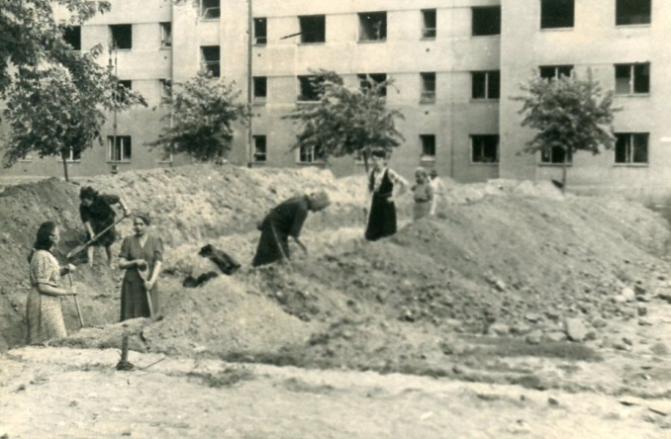
We reached Zoliborz that night, and our troops took up their positions in apartment buildings. With the help of the civilians we built barricades so that our soldiers could defend our independent territory against prowling German tanks. Still, the sky belonged to the German planes, which sometimes bombed us two or three times a day; and their cannons and mortars rained fire on us non-stop. Most terrifying were the rocket mortars, which came in group of eight, spreading death and havoc among the population. There were also unmanned Goliath tanks carrying explosives, which did a lot of damage; and constant machine-gun fire from outside buildings. To protect ourselves we dug connecting trenches across the streets and from house to house. Because of the constant bombing, the civilian population lived in the cellars. The nights were a little quieter; but our greatest problems were lack of arms, ammunition and food.
I was sent with the communication patrol to lay cables and organize the telephone service. My duties consisted of servicing field telephones and switchboards. The watches would pass on their observations about the movements of the German army to the switchboard operators, who in turn passed the information on to the commandant. Situation changed often. When the explosions got really laud, I was so fearful that I would hide behind our quartermaster. He was a large man, and his back seemed to offer good protection! (His pseudonym was “Old Man”, and he took good care of us as far as possible under the conditions. Food was scarce: our only meal every day was a coarse kind of oatmeal, with lot of hard hulls.)
Death became our close companion, and seeing people wounded and killed no longer made much impression on me. But it was different when I saw a young soldier from our platoon badly wounded. He was carried in on the stretcher before being moved to the hospital. I looked at him and gasped; he had no face, only one horrible wound. My first thought was very selfish: God preserve me from such a wound.

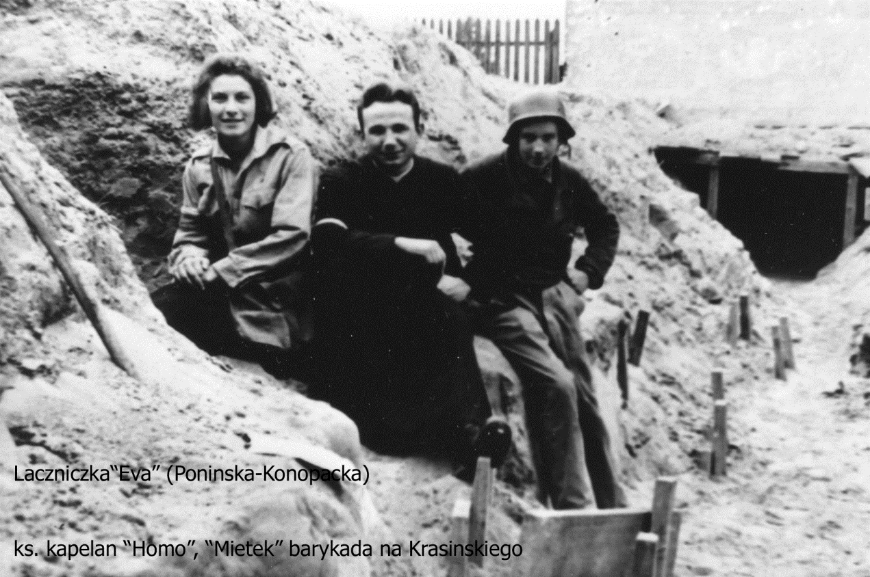
“Ewa” (Eva Poninska-Konopacka), the Chaplain “Homo” ( Wincenty Marczuk and “Mietek” (Mieczyslaw Kowalski)
In the second month of the uprising, the Soviet army began to drop arms, ammunition and military biscuits. It was their gesture for the Allies, showing that they were helping our uprising against the Germans. Our joy didn’t last long; the arms and ammunitions, thrown without parachutes, were usually damage beyond repair. One night, the sky suddenly lit up with flares. I could hear planes flying low overhead; then containers started to fall around me. I flung myself to the ground and tried to make myself as small as possible. It would have been terrible getting killed by a bag of biscuits!
We were on the go all the time, from one assignment to the next. It was the best to forget about the hovering death. Sometimes, though it was hard to forget. I remember crawling over a pile of rubble one sunny afternoon, when a ray of sunlight hit a strand of beautiful blond hair sticking out from among the broken bricks. To whom did it belong? Who was under this pile of bricks?
One particular day etched itself in my memory. I was awakened by the sound of the airplanes and the nearby explosions of bombs. As I left to report for duty at my station, the sun was shining warmly, its rays lighting the trees and shrubs in the courtyard. For a moment I couldn’t believe there was a war on. But at a street corner a few steps farther on there was an enormous bomb crater with human remains at the bottom. I got through an opened area that was often under German fire without incident, and reached the entrance to the Glass House just as the planes arrived. The bombs fell so close that we could hear them hissing as they fell. We breathed the sign of relief when the planes flew away.
The morning went by, then the afternoon. Again we heard the planes coming. Suddenly the whole building shook violently, and a cloud of powdery dust from the crumbling walls turned us into white mummies. Dazed but unharmed, I run outside, as the shaky silhouettes of other people emerged from doorways. I went to see were the bomb had hit. With disbelief I saw a gaping hole where the lobby full of people had been. The building had been cut in half. Shaken, I went by trench to the next building, crawling through the opening made in the foundation into the cellar. The ground floor was covered with stretches full of the wounded.
Among the moans I recognized a voice calling my name. It was my friend Klara, a nurse, who had been seriously wounded as she ran through the field. Because of heavy gunfire, nobody was able to reach her for many hours. With great difficulty, she had manage to put a pressure bandage on her own thigh to stop the bleeding; now she was waiting, without painkillers, for her turn to be taken to the hospital. (Our hospitals were in the coal cellars for safety. Our dedicated doctors and nurses worked day and night, often without sleep and by candle-light, to sew up mangled bodies and amputate useless limbs.)
I found somebody to help me carry Klara there, through the same field where she had been wounded. This time all was quiet. Exhausted by the day’s events, I suddenly felt faint. In order not to drop the stretcher, I had to put it down very quickly. She moaned loudly. Somebody else replaced me, and she was taken to the hospital. The doctor wanted to amputate her leg, but she wouldn’t allow it. She died the same night from loss of blood.
Another victim from our scouting Platoon 227 was the commander, Cadet Adam. He was killed during a German attack on our barricade. I had known him from the first day of the Uprising, and when I heard about his death I couldn’t stop crying. It took me quite a while to get over it. His body, wrapped in a black plastic, was buried next to the apartment building where we stayed.
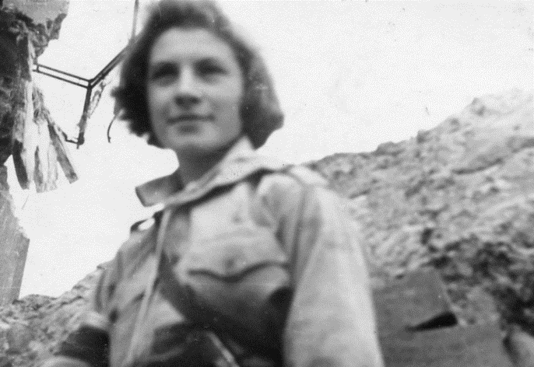
Members of Platoon 227 were called the “Canal Rats,” because these boys kept communication with the rest of Warsaw by going through the underground sewer system. The water had stopped running a few days after the Uprising began. Long lines of civilians formed at the wells for drinking water; washing was a luxury nobody could afford; and we dug pit toilets in the courtyards, since those in the buildings couldn’t be used. But now useless sewer served another purpose for the Home Army: they became our communication and supply lines, and an escape and evacuation route for troops. By the second month of the Uprising the Germans were damaging our telephone lines more and more often, and they had to be repaired constantly. I gladly volunteered to do this job; I preferred moving around to sitting in one place. The job was quite simple: I would check for broken wires with a special telephone, do the repair, and then check the connection. But constant bombardment, explosions and shelling were damaging the wires faster than they could be repaired, and many people were killed and wounded while repairing the lines. The commander eventually decided to use us as couriers.
Once I was sent on a secret mission, to replace a guide who had fallen ill. This guide used to lead our patrols from Zoliborz to the German occupied suburb of Bielany, where arms and ammunition were hidden in an orphanage. I was given a pistol and four grenades, and told to use them only as a final resort. There were seven of us: me, and six strong armed men to carry the heavy supplies. We left at midnight from the old factory building. We had to cross an opened area of several kilometres of sand dunes, without any building or vegetation, and secured by the Germans with machine-gun fire. We walked like shadows; when flares lit up the dunes we would fall down and hug the ground. A fight with the Germans was to be avoided at all costs; there would be no help coming if we got in trouble. Fortunately, the Germans didn’t like to come out at night.
Finally we arrived at orphanage and got our load. We started back immediately, to take advantage of the darkness; but at dawn I realized that I had lost my way. The situation was very dangerous, but I didn’t anyone know what had happened – I didn’t want the soldiers to panic. Finally we did make it back, though not to the positions we were expected. I was greatly relieved since it was my responsibility to bring everybody back safely.
The last days of the Warsaw Uprising are still very vivid in my mind. Catastrophe seemed unavoidable; still, we didn’t consider capitulating. The complex of apartment buildings occupied by our command, “Giraffe,” occupied 20 and 29 Krasinski Street as well as the convent of the Sisters of Resurrection. All these buildings were heavily damaged by bombs and artillery fire; the large convent was exposed to enemy fire from three sides, where there were opened fields. There was only one trench joining our positions. After heavy artillery fire, the Germans often attacked the convent with tanks and infantry.
These attacks were always repelled; but in the final days the situation changed. The artillery fire on all three positions was intense and devastating, and we thought it would never end. Attacks by the tanks and infantry came in waves. One of the boys, codenamed “Fox,” described it this way: “The grey dawn was beginning to light up the sky and the flood of fire and the steel exploded around us in a never-ending assault. Shells were landing one next to the other. Every square metre was covered with craters.” Communication with the convent was broken when corner of the building nearest it collapsed, its ruins burying part of the trench. Since the convent was our bastion against the German attacks, it was essential to regain communication at any cost.
Our commander “Tatar,” asked for volunteer, and I decided to go. Our boys told me that it was a difficult, if not impossible, task – they didn’t believe I could reach the convent. It was already heavily damaged by artillery shells; now the Germans used a flame thrower to start fires on the top floors. But I was determined to go. Once I left the safety of our building I was in an open area, all alone. I crawled slowly over the pile of bricks from the ruined building, trying not to be noticed by the Germans. I saw the little fountains of sand rising into the air as bullets hit the ground next to me. Finally I was able to jump into the remains of the trench. In front of me there was a big hole in the convent wall, the only entrance, and it was under fire from a Tiger tank’s powerful cannon. I said to myself, “I have to move immediately when it fires its next shot.” Then I hesitated: “If I stumble, what then?” I tried not to think; I just jumped, I was lucky. No shots hit me as I raced inside and gained the safety of the convent walls.
But the situation inside was tragic. There were many dead and wounded, lying in the large hall in the basement. More bandages were needed, and the ammunition was almost gone. The Germans were attacking the windows, and there was hand-to-hand combat in the wing. While I was waiting for “Jan”, the convent commander, a sixteen old boy was brought in with one leg missing. He was conscious, I thought that he didn’t know about his leg; but he did know, and was in despair. “How will I fight the Germans?” he said. In his distress, he was still thinking about the war. But there was no time for conversation; I had to go back and report on the situation at the convent.
In the meantime the German tanks had withdrawn from their positions at Krasinski 29, so the return trip was a little easier. After I reported back, we began to bring ammunition and dressings to the convent, which had repulsed the German attack by the time I got there. In spite of being totally exhausted and grey with dust, we all breathed a sigh of relief. Reinforcements arrived: a unit containing our youngest scout fighters, called “Zawiszaki.” They moved along the corridor grenades as the Germans renew their attack and tried to enter the building.
I had to report back to my post; but later found out what had happened at the convent. Soon there was another danger: the weakened walls could collapse at any moment. Two girl couriers and a scout named Andrew, not realizing the danger, were running under the wall when it collapsed. The two girls were killed outright and Andrew was buried up to his waist in the ruined walls; he couldn’t free himself. His comrades tried desperately to free him with their bare hands, but to no avail. Andrew begged them to leave him, with a pistol and ammunition so he could defend himself to the end. They granted his wish. His fellow scouts, cut off from the rest by the fallen wall fought to the last bullet. Those who didn’t perish were taken prisoner.
The Germans were preparing for the final attack, intending to take the whole building. Commander Jan unable to retain his position, decided to retreat. The upper floors were already on fire; now, at his order, the basement was set on fire too as well. Gasoline was poured over the beds where the dead lay, and the smoke covered the retreat of those remaining.
But Tatar was unaware of all this, and send me to the convent again in the evening with orders to retreat. My heart was heavy with sadness at this; but when I reached the building, the stillness surprised me. The large corridor at the entrance was filled with smoke. I went deeper into the building, calling the commander’s name. There was no answer. The only sound coming from the depth of the building was the series of shots. Finally, I realized that nobody was there, and I was mistaking the explosion of burning ammuni9tion for the sound of fighting. Almost suffocating from the smoke, I ran into the basement hall where the wounded had lain that morning. There was no one there but the dead, burning in their beds. I realized that I was totally alone. At first I was paralyzed with fear, thinking that may be the Germans had cut off my escape. I knew about their atrocities and sadism. In panic I ran for the exit, but there was no one around – only the sun setting red.
As I stood thinking that this was the end of a long and momentous day, two civilians came up and told me that there were two wounded soldiers in an abandoned building. I found a nurse, and we went with a stretcher to the ruined building. Part of it was burned down, and the wounded were in the coal cellar. It would be difficult to get them out, because the street entrance of the building was already occupied by the Germans. We had to bring the wounded one by one to the ground floor and evacuate them through a window on the other side. This was very painful for the wounded, but it had to be done; we knew that in spite of the Geneva Convention, the German were executing our wounded.
New orders came to retreat in the direction of the River Vistula. We still had some hopes that help would come. The whole Giraffe command moved out and gradually all our troops followed I went in search of the Platoon 227, but couldn’t find them. They were at the old quarters; and in the chaos of the general retreat of the Home Army, the orders hadn’t reached them. I rushed back through the underground maze of cellars, packed with civilians. Somebody put a teaspoon of jam in my mouth – a deeply moving gesture, because there was much hunger. I found a group of lost soldiers trying to find their platoon. There was a short downhill path to the shallow trench that led to the Glass House. It was often the site of the heavy fire, and this time it was no exception. After attempting it and barely escaping with my life, I tried another route. The boys followed me one by one.
All our fighting units were now concentrated around the Glass House, and it was there that we heard about one-hour armistice. Our boys rested and cleaned their weapons. Soon afterwards, we heard that our surrender had been arranged. It was a terrible shock – we couldn’t believe it. So many sacrifices, so many lives, all for nothing! We sat in gloomy silence devastated.
I stayed the night beside the burning Glass House, where two months ago the Uprising began we were so full of hope. In the morning our troops, fully armed, marched between two lines of heavily armed Germans to the square. The Germans placed tanks at the corners of the square with their guns turned in towards us as we marched, laying down our arms. On the 30th of September 1944, Zoliborz capitulated.
I was decorated with the Order of Virtuti Militari and promoted to Sergeant in the underground army. When decorated I realized that many others who deserved this distinction more, didn’t get it, because many heroic deeds had no witnesses. Nevertheless I was very proud to be chosen to represent them all.
WISIA’S REPORT
What went on in the other parts of Warsaw during the uprising is best described by Wisia, who later became my sister-in-law. She was a nurse, picking up the wounded wherever they fell and taking care o0f them. On the evening of September 1st, as it got dark, the command decided to retreat from the area. The only way to retreat was to use sewers taking wounded who could walk. The badly wounded had to stay behind. Wisia decided to stay with the severely wounded and said goodbye to the boys of the unit.
In the morning the Germans burst in, screaming “Bandits, bandits!” The commander asked her if she and the wounded were the only people in the building. She said “Yes,” but he kept his gun on her and ordered his soldiers to check under every bed to make sure she was telling the truth. Her face was as white as a sheet, and fear made her speechless. After the inspection the German lowered his gun and ordered the wounded to be moved to the hospital at Dluga Street.
The Germans were ready to leave and their voices seemed to be gentler. Wisia turned to the commander and asked him if his soldiers could help her to move the wounded. He flew into rage, pointing his gun at her again. “German soldiers will not carry Polish pigs!” he screamed. Scared out of her wits, she stammered, “I will manage, I will find somebody to help me.” The Germans left, warning that they will be back soon and anyone remaining would be shot.
Wisia run out into the street and begged passersby to help her to move the wounded. Soon she found some helpers; they had to go to the hospital first to get the stretches. She watched to be sure that everybody was taken. In the hospital courtyard was a piece of cloth painted with an enormous swastika. Suddenly the German ambulances arrived, and the Germans started to remove their own wounded (who a few days before had been our prisoners and were treated by our doctors for their wounds.) The Germans were also looking for somebody. Finally they found him: a young Polish partisan with a crew-cut. They took him out to the courtyard and shot him. Wisia never learned who he was.
There was much worse to come. Around noon, the Germans arrived back in force. Wisia saw a great commotion in the courtyard: those who could move were crawling from their rooms, hoping to save themselves. She went back to the hospital to help a young soldier closest to the door. He could only use the one leg; the other was badly wounded, bent at the knee. She gave him a broom for support, which he used on one side as a crutch; and leaning heavily on her shoulder, he left the room. Behind the door there were two Germans with automatic pistols. Wisia and the wounded young man began the slow descent, step by step. One of the Germans directed her to the courtyard, where they were told to stand on one side with the other wounded. The civilians were on the opposite side. The distance between the two groups was getting smaller as more people came out and filled up the courtyard. German soldiers walked up and down between the two groups to keep order.
Suddenly she had a premonition that something terrible was about to happen. She pulled the wounded boy, whose name was “Ikar”, to the civilian side. But a German noticed them and ordered them back. Then another came up and said, “Nurse, you are not needed here. Go to the other side.”
It dawned on her that this side meant death. Suddenly her legs felt paralyzed; but the Germans pushed her roughly to the civilian side. She stood there for a few minutes, observing everything carefully. The situation was becoming more and more chaotic. The Germans probably received fresh orders, because they kept looking at their watches and began to regroup the new comers, whose numbers were constantly increasing. They shouted loudly and their behaviour became even more brutal. Wisia took advantage of the confusion and moved Ikar again to the civilian side. Again a German noticed, but this time he let them stay there.
Suddenly there was enormous outcry. She could hear shooting in the building and the noise of airplanes flying overhead. They began to bombard the hospital with incendiary bombs; and at the same time, the Germans opened fire with machine-guns on the wounded gathered outside. It was hell. The screams, and the clouds of dust and smoke, rose to heaven. She stopped thinking. She became part of terrified crowd, waiting for the end.
Her heart pounding, she turned her head away so as not to look at the massacre. By then, the hospital was burning fiercely. Then through the smoke she noticed their army chaplain, Father Rostworowski, standing with his hand outstretched to give the last blessing to the dying. Clouds of dust and smoke blocked her view; but whenever the wind blew them away, Father Rostworowski still stood there with his hands raised in the prayer to God.
Wisia found out later that the Germans shot 430 people at the hospital in their beds and in the courtyard.
THE PRISONER OF WAR
As soon as Platoon 227 had laid down its arms, we became prisoners of war and were marched away under German guard. Knowing that the Uprising has ended, the Soviet Army began to shell Zoliborz. Shrapnel exploded nearby, and our German guards crouched in fear. But we were too depressed to feel fear. And despite the shock of defeat and our sorrow for the lost lives, we did also feel relieved that nobody would be killed or maimed that day.
The Germans took us to Pioner Park in Powazki for the night, and then the next day to Pruszkow. The concrete floor of the huge warehouse was so crowded that I couldn’t find a place to lie down for the night. Boys from my platoon tried to make room for me, but they stretched out in their sleep and I lost my place.
The next day we were packed like sardines in the cattle car and sent to the camp of Gross Lubars, near Magdeburg. Our train often stopped to let military transports go through. We could hear Allied bombs exploding quite close. We were worried; it would be a joke to survive the Uprising only to be killed by American bomb.
Gross Lubars was a very large camp, with many wooden barracks. A neibouring camp was occupied by prisoners of war from the Allied Forces. When the wounded began to arrive from Warsaw I visited them every day, singing scout and partisan songs to cheer them up. The saddest one were the boys who had been blinded in the Uprising. One gave me a Polish Eagle fashioned from a metal can. I also visited seriously wounded girls in the hospital. One of them was Anna, whose sister Krystyna, a nurse, was my troop leader in Warsaw. Anna was badly wounded, with many dangerous shrapnel wounds. At one point, she was close to death. Gradually she recovered; but it was many years before all the pieces of shrapnel were out of her body.
Couple of weeks after out arrival at the camp, the Germans sent sixty of us girls to work in a war factory in a little village of Parchen. It was only a country road with a few houses, a movie theatre and a one story building with a flat roof that looked like a huge garage, but was in fact a factory that produced parts for airplanes and tanks. Our arrival caused an enormous excitement among the Dutch and Belgian forced labourers there: they had never seen female prisoners of war before. (We still wore our white and red armbands bearing the Polish Eagle and our platoon numbers.)
Although our work began at 6 a.m. and ended at 6 p.m., we had comparative freedom at Parchen. We were housed in the movie theatre, with straw on the floor to sleep on. There were no guards, and we were free after work. When the weather was fine, we liked to take walks in the forest. For breakfast we had bread, margarine and marmalade; for dinner, thick vegetable soup with meat. In the factory, we were assigned to different types of work. Some of the girls did welding; I was given work at the electric lathe. My master was a good-natured German who explained to me patiently what I was expected to do. I refused to cooperate, though – according to the Geneva Convention, we weren’t supposed to be employed in any war production work, and I certainly didn’t want to help the Germans in their war effort. My master soon realized what I thought when he saw big pieces of steel damaged and the lathe machine stuck! In despair, he let me do anything I wanted, as long as I didn’t touch his machine. I took advantage of this privilege to visit other girls at their work stations, or to sleep in the corner behind some tools.
This state of affairs didn’t last long, unfortunately. One day an SS officer came to suggest that we relinquish our prisoner of war rights and join the civilian population. In return we would receive better quarters and better food. He gave us a couple of days to think things over. We decided to remain the prisoners of war. The Germans were not pleased, and decided to punish us. Next day guards appeared carrying rifles; and from then on we were taken to work under guard and even guarded in the factory – to the great amazement of the Dutch and Belgian workers. Our movie house dormitory was lit all night long, and we were not allowed to use the outdoor toilet; a bucket was brought in instead.
Eventually we were taken off factory work and made to work outside, carrying heavy beams of wood back and forth. Our food also changed for worse. After six weeks of this, we were taken back to our previous camp; and two days later loaded on a cattle train and sent to a POW camp called Stalag VIC Oberlangen, near the Dutch border.
When we arrived at Christmas Eve, and didn’t get any food that day – perhaps the camp wasn’t ready for our arrival. Stalag VIC Oberlangen was an all- women camp, situated in the barren area of swamps with no villages in sight. Barracks each provided room for 200 people; and we girls from Zoliborz stayed together in barrack 5. Inside there were three-tiered bunk beds. My friend Lucyna and I choose to share the top bunk, although there were no ladders. We reasoned that the straw covering the planks would fall on others, not us! At the end of the barracks was a washroom with 20 taps with running cold water – in the morning, they were usually covered with ice. It took courage to undress and wash in the icy water. Eack barrack had only one metal stove, heated with turf bricks.
Every morning we had to stand at attention in front of the barracks, while our company leader reported the number of prisoners and the number of sick to the German SS officer. Then the Germans, who were always accompanied by the vicious dogs, would count us again. This was a lengthy procedure, considering that there were over 1,500 women. Then our leader would assign us chores for the day: cleaning the barracks, helping in the kitchen, bringing the loaves of bread from the warehouse, supplying turf for fuel, bringing the large buckets of soup from the kitchen.
The least popular job was emptying ditches. Every so often, a German farmer would arrive with a horse-drawn tank to empty out the liquid manure. These primitive outdoor toilets were deep and dangerous: they were slippery in winter, and it was easy to fall in. This happened once to a friend of mine during the night. Fortunately, she wasn’t alone and was pulled out before she could drown. None of us had any extra clothing, so she had to stay in her bunk, covered with straw, until her clothing was washed and dried by her friends. (There was talk among us of an Italian soldier who had once drowned in the ditch, whose ghost would appear from time to time.)
Along with hunger, vermin was our worst problem: we fought a losing battle with bedbugs and lice. I was still wearing the same clothing I had worn when I had left home to fight the Germans the only addition was a military coat. At night, I couldn’t sleep for hours because of the bugs, and the sucking feeling of an empty stomach didn’t help. Our only consolation was the sound of the Allied bombers who flew in waves over Germany at night. We often thought with envy about the pilots, who were free men.
We were constantly hungry, and our main topic of conversation was food. Sometimes I was able to get a potato, which I carefully cut into thin slices and baked against the metal stove. Our greatest joy was to receive a parcel from the Red Cross, containing chocolate, condensed milk, cocoa, cans of meat and cigarettes. (We were supposed to get these every month, but I only got two in the six months.) When parcels arrived, we would have parties for many days. How long a parcel lasted depended on the character of the owner. Some ate everything practically in one sitting; others divided the food into small portions. I belonged to the group which ate everything very fast, while Lucyna liked to make hers last.
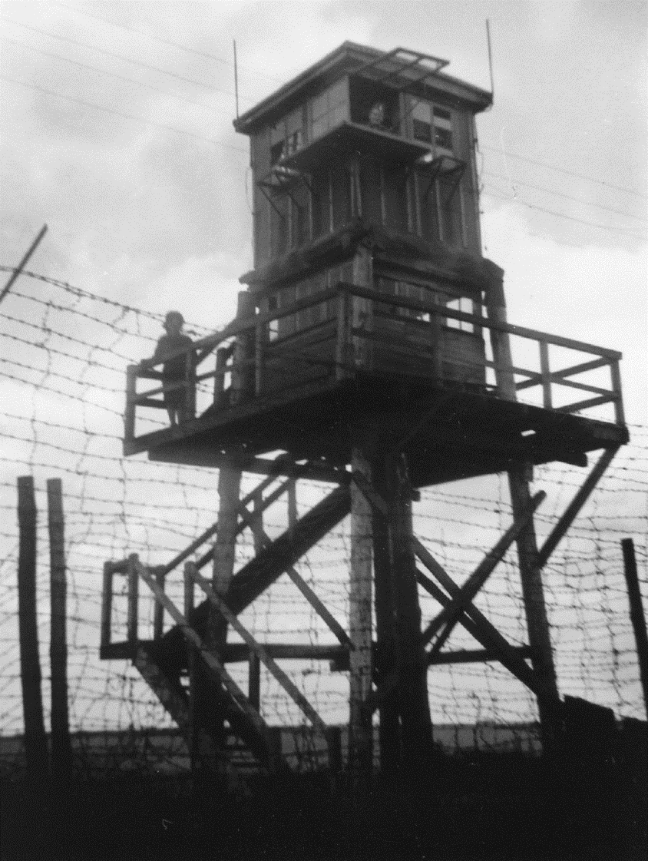
Stalag VIC Oberlangen – picture taken after the liberation in 1945
Time dragged. Every day felt like a month. We visited friends in other barracks and took walks along the barb wire fences. Lectures were organized on various topics; languages were taught a play was produced. Still a deep depression got hold of me again and I lost an interest in life. Fortunately, others were more active. At Easter, celebrations were organized by our Italian chaplain, who didn’t speak a word of Polish. Masses were celebrated in an empty barrack and our camp artist drew a charcoal silhouette of Christ behind barb wire. On Good Friday, I volunteered with a group of other girls to keep a guard of honour at Christ’s tomb. We changed over every half an hour, but thirty minutes was too much for two girls; they fainted, too weak to stand. During the Easter Sunday Mass, girls served as altar boys while the priest gave a general absolution and Holy Communion.
We knew that the Allied front line was approaching fast. The German became very restless and treated us better than usual. Then one day the shots could be heard. Our commander ordered us to stay inside the barracks, to be out of the way of stray bullets. Then suddenly, through the windows, we saw tanks – and they were not German tanks! Nobody could stop us to running outside. We heard commands in Polish, and knew that we were free – liberated by the advance troops of the First Polish Corps of General Maczek. That day was April 12, 1945.
Fifty years later, there was a veterans’ reunion in Warsaw. It was a very happy and emotional meeting of survivors, brothers in arms. I met Lucyna again, though at first I didn’t recognize her because she was wearing a nun’s garb. As for the “boys,” I could hardly believe that these balding, greying gentlemen were the same young Boy Scouts who had fought so bravely many years ago! But then the fifty years melted away in front of our eyes, and we were young again as we relived our experiences and talked about our lives since we had last met.

